32.44: a) The energy density, as a function of x, for the equations for the electrical and magnetic fields of Eqs. (32.34) and (32.35) is given by:
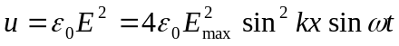
b) At 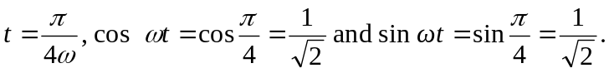
For
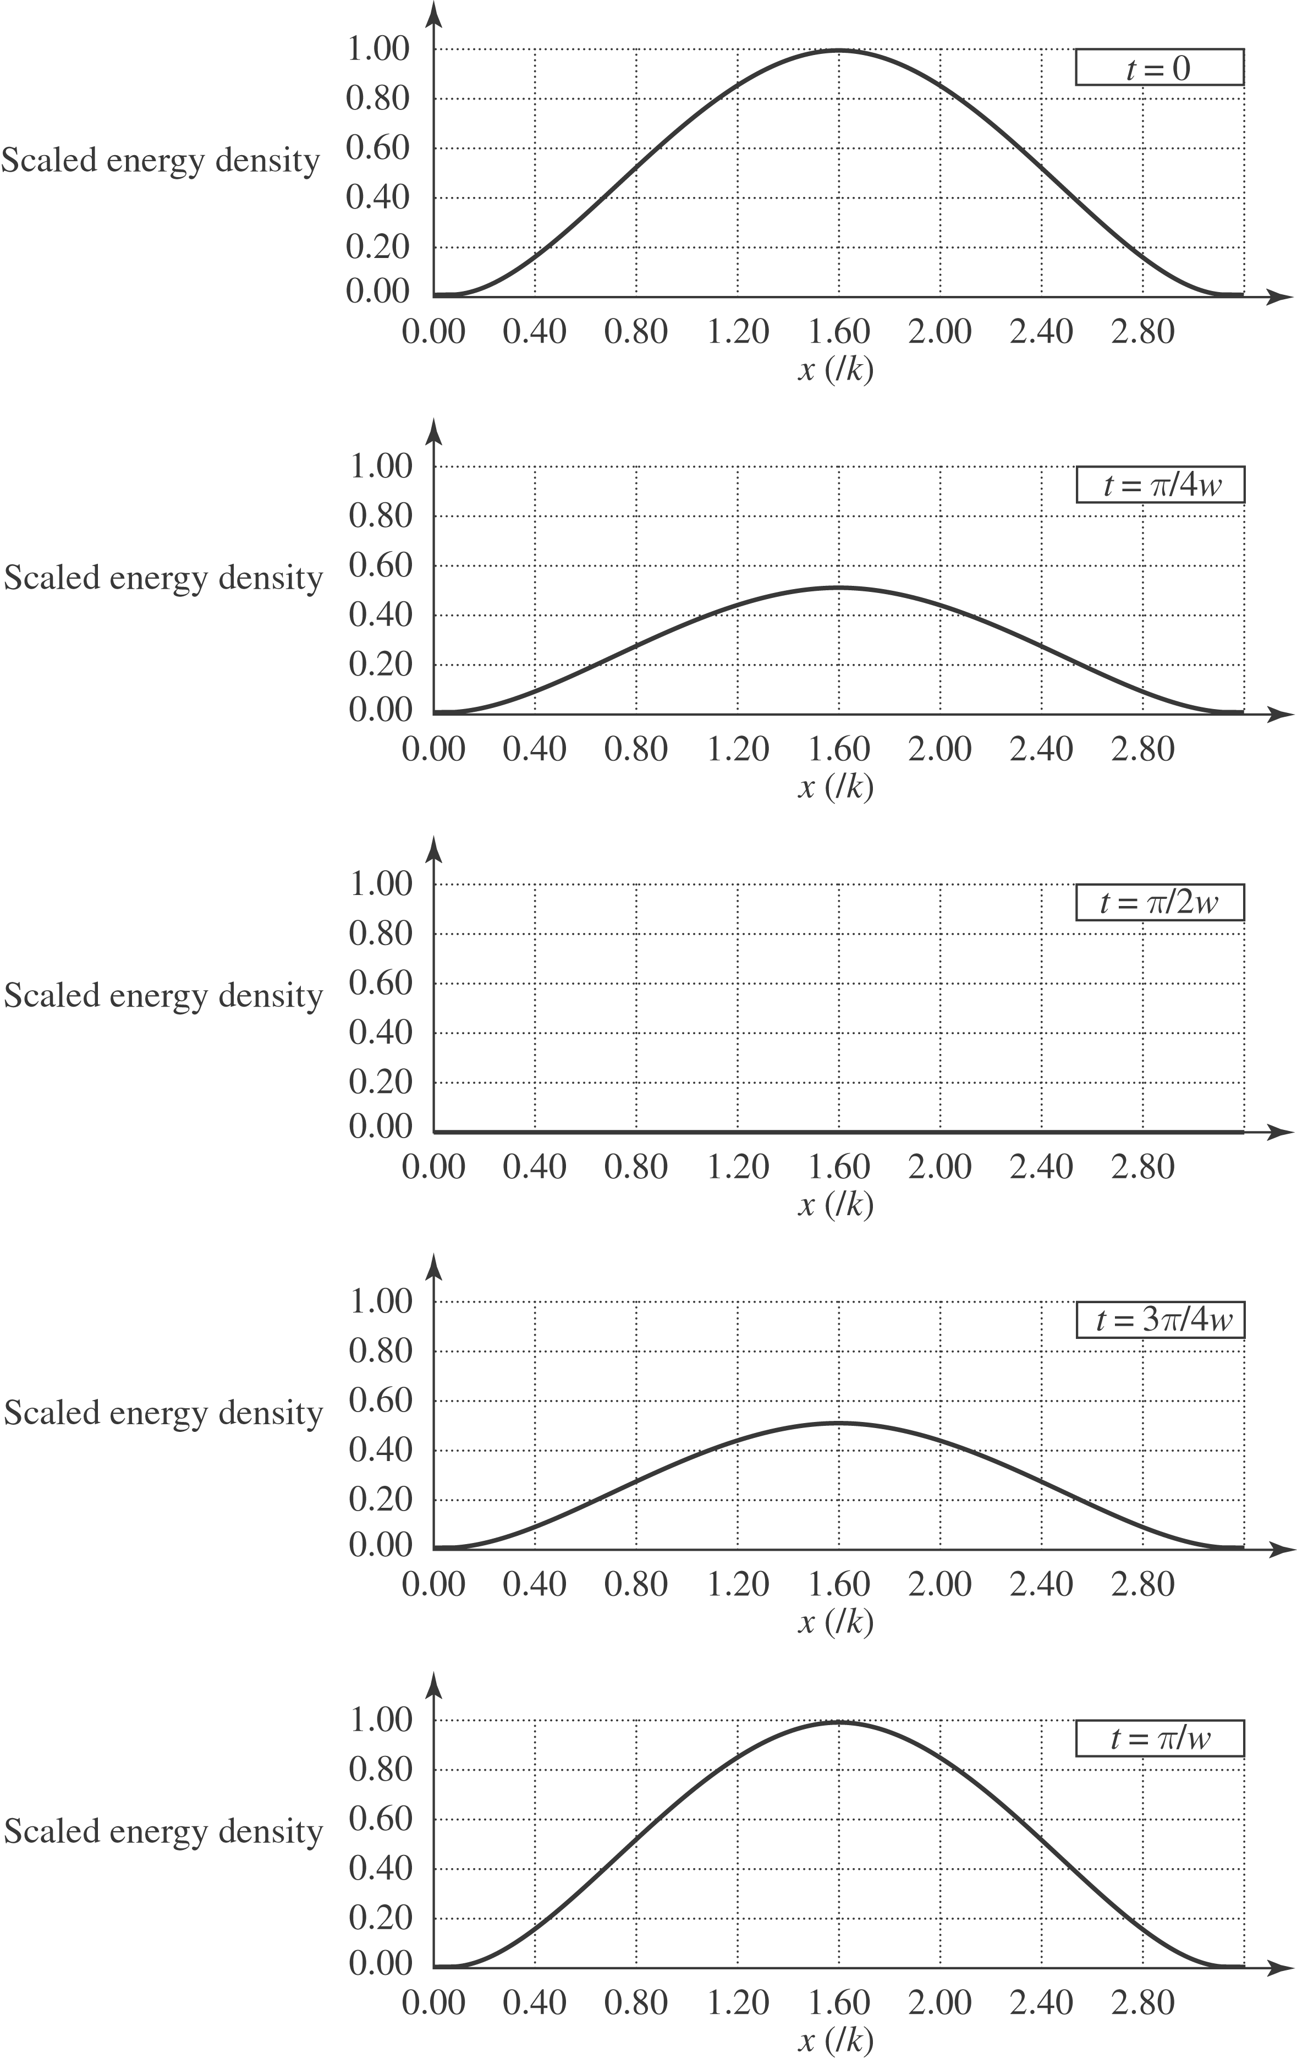
And for 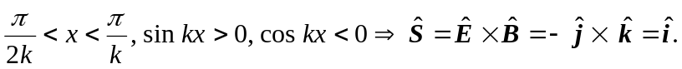
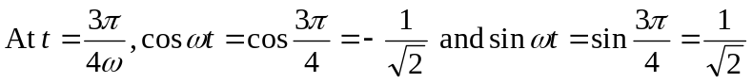.
For 0 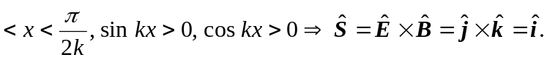
And for
c) the plots from part (a) can be interpreted as two waves passing through each other in opposite directions, adding constructively at certain times, and destructively at others.

